# 1 Design

This chapter will be devoted to present the design stage of our system. Designing is a creative process that describes the manner in which our system works. We will start by presenting our architecture design, then we move to the general conception and finally the detailed design.

## 1 General design

Our project is essentially based on two main parts as described before. In the next section, we present the architecture of the system.

### 1.1 Architectural design

Architectural design refers to the high level structures of a software system, the discipline of creating such structures, and the documentation of these structures. These structures are needed to reason about the software system. Each structure comprises software elements, relations among them, and properties of both elements and relations. It’s about making fundamental structural choices which are costly to change once implemented. Architecture design choices include specific structural options from possibilities in the design of software.

#### 1.1.1 Big Data architectural design

In the last chapter we fixed what we will be using in term of patterns and tools.Now,we are able to just start implementing our lambda architecture.

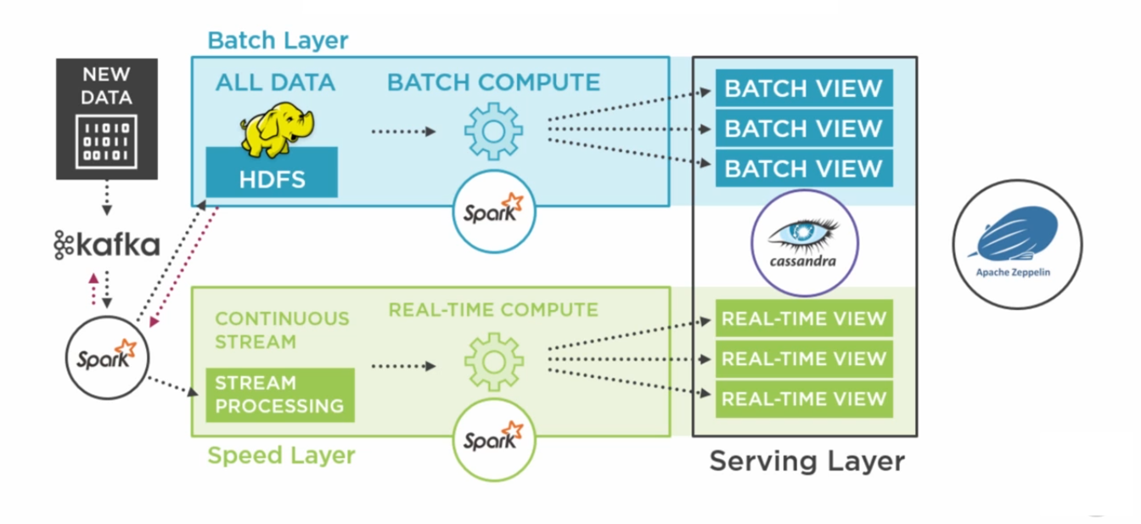 [filiales et clients de Sofrecom.]Sofrecom’s subsidiaries and customers. Figure taken from [?].

#### 1.1.2 Microservices architectural design

After fixing all patterns and choosing which technologies we would like to implement , it’s time to make the last step. The next figure show our microservice application architecture in it’s first versions:

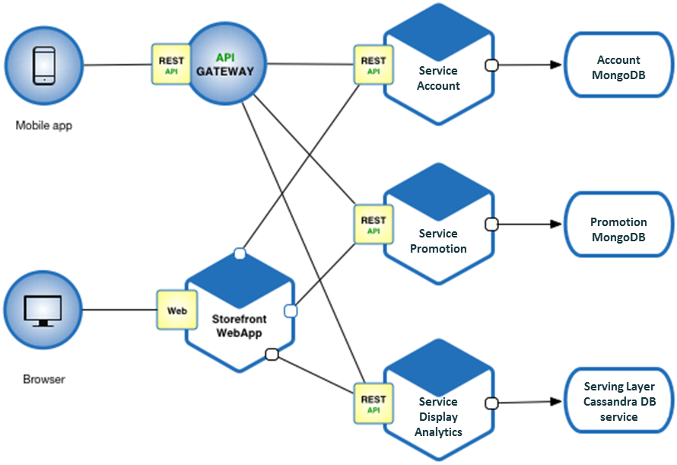 [filiales et clients de Sofrecom.]Sofrecom’s subsidiaries and customers. Figure taken from [?].

#### 1.1.3 Deployment architectural design

We have designed our deployment architecture showing all containers communication and linking pipelines. The next two figures show the big data and the microservices deployment architecture.

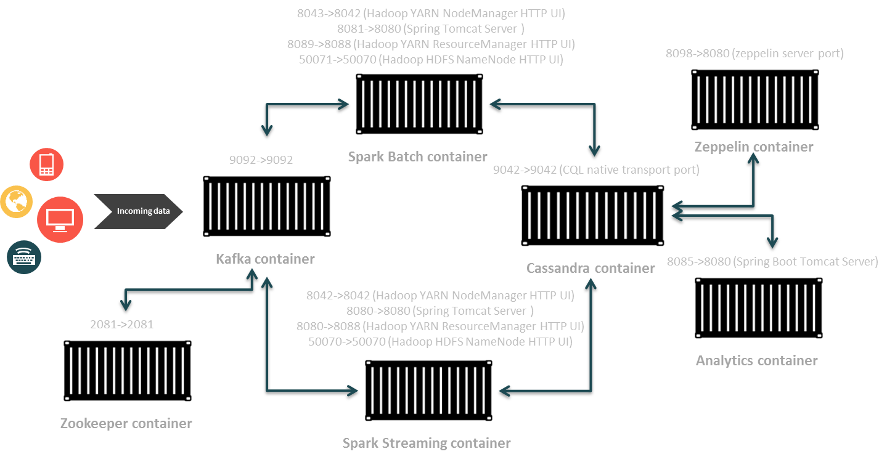 [filiales et clients de Sofrecom.]Sofrecom’s subsidiaries and customers. Figure taken from [?].

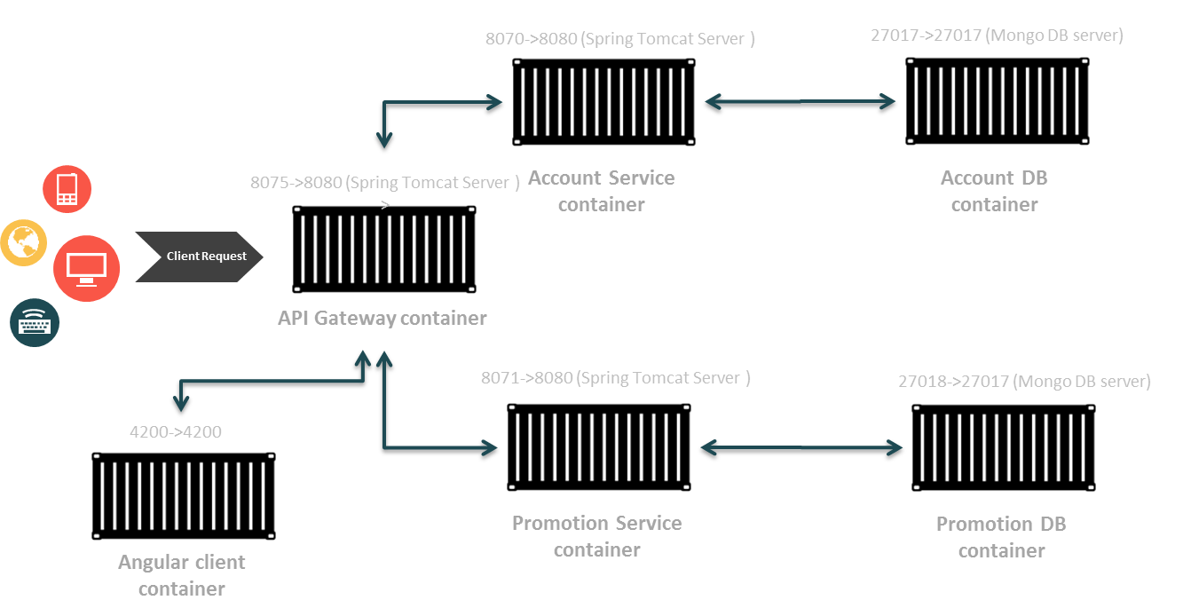 [filiales et clients de Sofrecom.]Sofrecom’s subsidiaries and customers. Figure taken from [?].

#### 1.1.4 Summary

Finally, the next figure resume all patterns and architecture discribed before.

 [filiales et clients de Sofrecom.]Sofrecom’s subsidiaries and customers. Figure taken from [?].

## 2 Detailed design

This section will be devoted to the detailed design of our application, we start with the package diagram. Then we present the class diagram. And finally we model the dynamic aspect of the system using sequence diagrams

### 2.1 Package Diagram

A package diagram is a collection of static modeling elements (classes, packages, ...) that shows the structure of a model. It describes all the classes and their associations

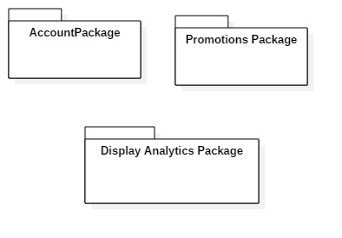 [filiales et clients de Sofrecom.]Sofrecom’s subsidiaries and customers. Figure taken from [?]. Packages in the microservices architecture are totally separated . This is one of the benifit of this approach. When creating a new fonctionaly just plug and pluck.

• Promotions package : this package handle promotions managment like creating , updating , searching or adding promotions.

• Account package : this package handle users managment like creating , updating , searching or adding promotions. This package expose a very important fonctionalty that allow updating user location. Users location are display in a heatMap.

• Display analytics package : This package takes care of data analytics results and display it in a dashboard. Allowing users to see realtime analytics results.

### 2.2 Class Diagram

After completing the preliminary design phase, we will now detail further this design by presenting the class diagrams of the different packages.

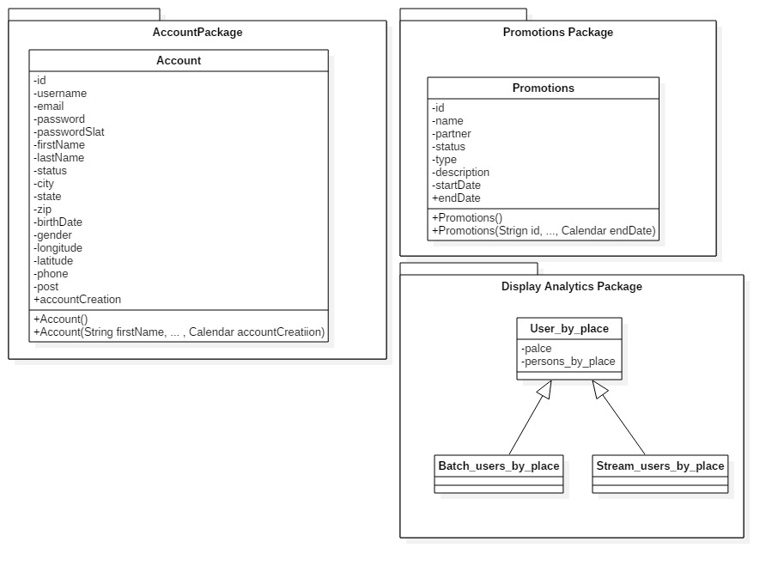 [filiales et clients de Sofrecom.]Sofrecom’s subsidiaries and customers. Figure taken from [?].

• Account class : This class is used to define the user informations. It presents the Name, first name, email, login, passwords , essentially the longitude and latitude used for the heatMap chart ...

• Promotions class : This class is used to define the promotion informations. It presents the name, partner name, status, type, description ...

• Users by place class : this class is an abstract class that have two implemention which are Batch users by place and streaming users par place. It allows as to track users basing on locations and determine wich place is the most visited one. *For exmaple : if i am having a supermaket , by putting beacons in the each store corner , i will be mesuring the users vist by place in real time .*

### 2.3 Object Sequence Diagrams

A sequence diagram is an interaction diagram that shows how objects operate with one another and in what order. It is a construct of a message sequence chart. A sequence diagram shows object interactions arranged in time sequence.

#### 2.3.1 Display analytics sequence diagrams

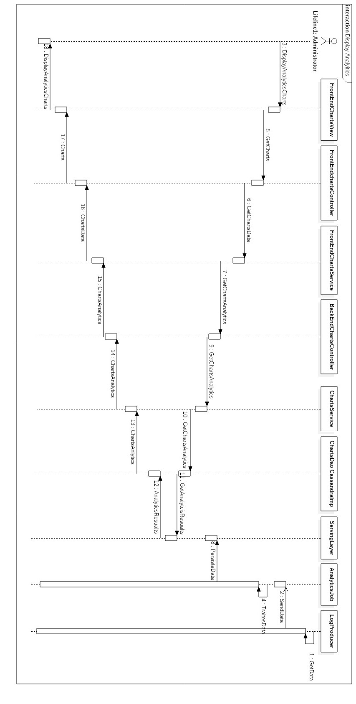 [filiales et clients de Sofrecom.]Sofrecom’s subsidiaries and customers. Figure taken from [?].

#### 2.3.2 Display analytics sequence diagrams

:

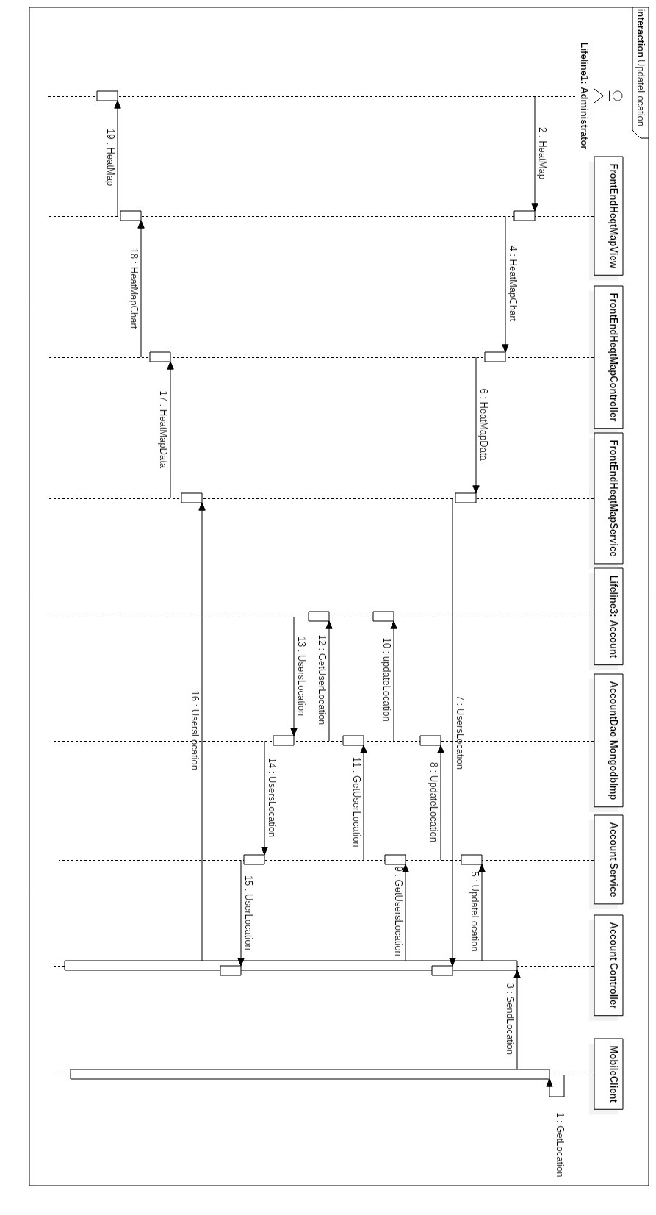 [filiales et clients de Sofrecom.]Sofrecom’s subsidiaries and customers. Figure taken from [?].

## 3 Conclusion

Two main parts are waiting to be implemented, the first one is the lambda architecture and the data analytics strategy. the second one is the microservices approach and the application logic.